Certificate of Achievement

This Acknowledges That
First Last

Participated in
Mosaic Creative Writing Contest 2019

School, Grade #

Entry Type

May, 22  2019 | 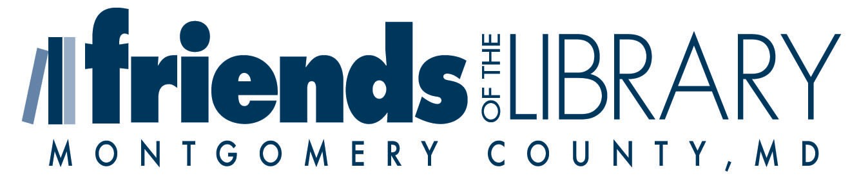  Signed, Ari Z. Brooks, Executive Director

